OO Analysis And Design Questions

# Week 3

1. Identify the steps of the OO analysis process.
2. Give a brief summary of the purpose of each step.
3. Differentiate between external and temporal events?
4. What is the purpose of creating a Domain/ Conceptual Model?
5. Explain the meaning of the following terms using the diagram below
6. *Multiplicity*
7. *Association relationship*
8. *Association Class*
9. *Link attribute*

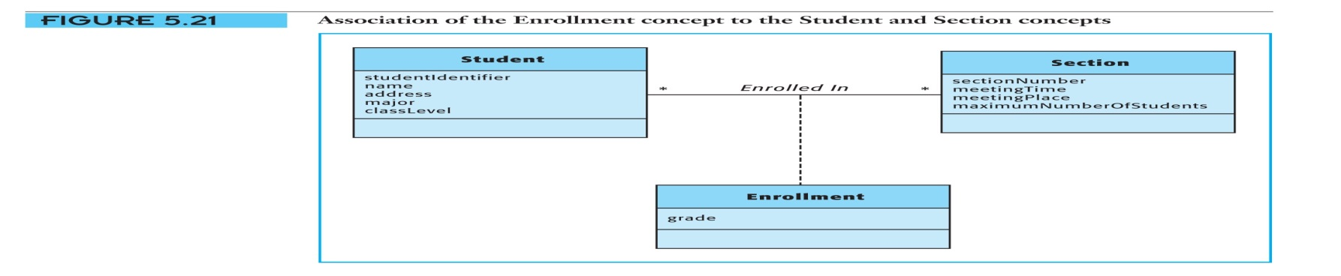

1. What is the purpose of creating a system sequence diagram ?
2. What are the main elements shown on a system sequence diagram?
3. What is a system operation contract?
4. What are the main parts of a system operation Contract?
5. Explain the meaning of the Factory pattern using the following diagram

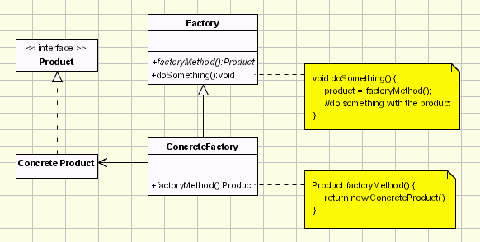

# Week 4

1. What is the purpose of the singleton pattern?
2. Explain the meaning of the singleton pattern using the following model

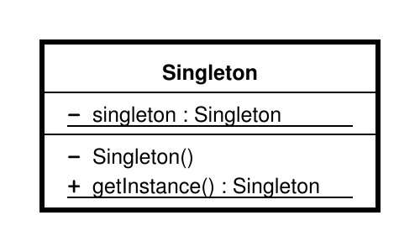

1. Differentiate between the following terms as used in Object Oriented Analysis and Design
2. *Link and Association*
3. *Object and Class*
4. Explain the meaning of an object diagram using the image below

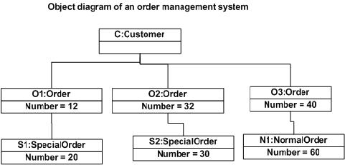

1. Draw a Class Diagram that would support the object Diagram in question 4.
2. Explain the meaning of the following properties of an object
   1. *Identity*
   2. *State*
   3. *Behviour*
3. How is a constraint illustrated on a class Diagram?
4. Explain the meaning of a derived attribute using the following model?

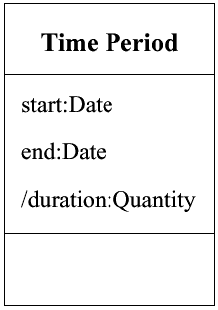

1. How is the visibility of an attribute shown on a class diagram?
2. Explain the meaning of the Abstraction Occurrence Pattern using the following model s

